**Assignment 4 Hall of Fame/ Hall of Shame**

What distinguish a good user interface from a bad interface. Let us list down some of the properties of a good interface:

* Good use of screen area
* Frequently accessed items as buttons or icons
* Functionally embedded in macros
* Cache repetitive task
* Grouping of similar tasks
* Good color and contrast choice
* Icon/button size according to screen area
* Maximize screen area for features that are specific for a job (Tabs)

The inverse should generate a bad interface.

Let us get into an ongoing battle, in the Linux world, of Wayland vs Unity. The test OS are Fedora 32 and Ubuntu 20.004 LTS. Fedora uses Wayland as its default graphic display manager and Ubuntu uses Unity 8.

**Fedora 32 Main Desktop:**

A sleek and minimal design that allows maximum work area along with navigation/search menu provided via Super key. The applications can be pinned as icons on the left navigation pane. The running apps are also shown in the left navigation page. But, the functionality is only visible when you press Super key. Thus, provides maximum work area without any distraction.

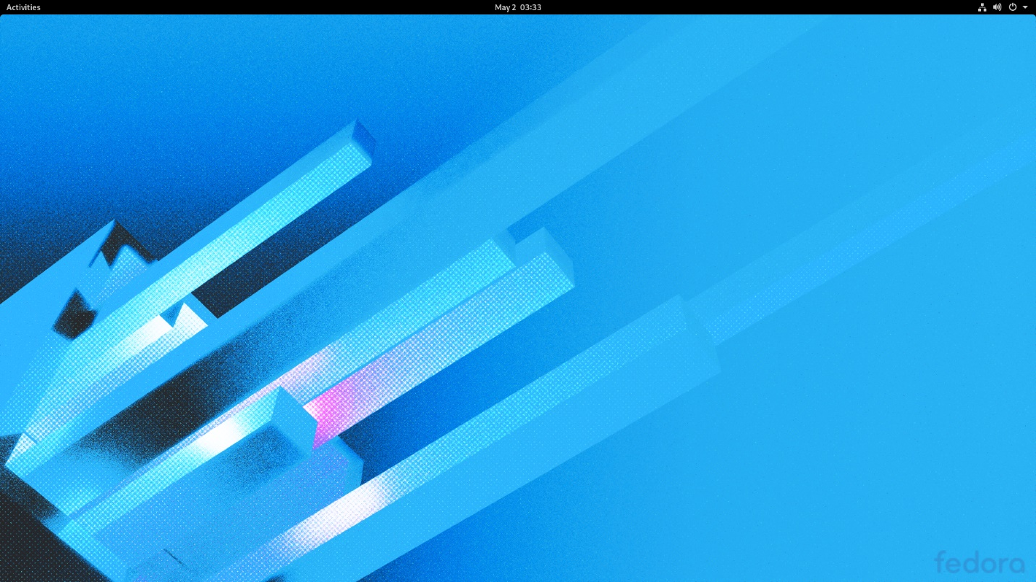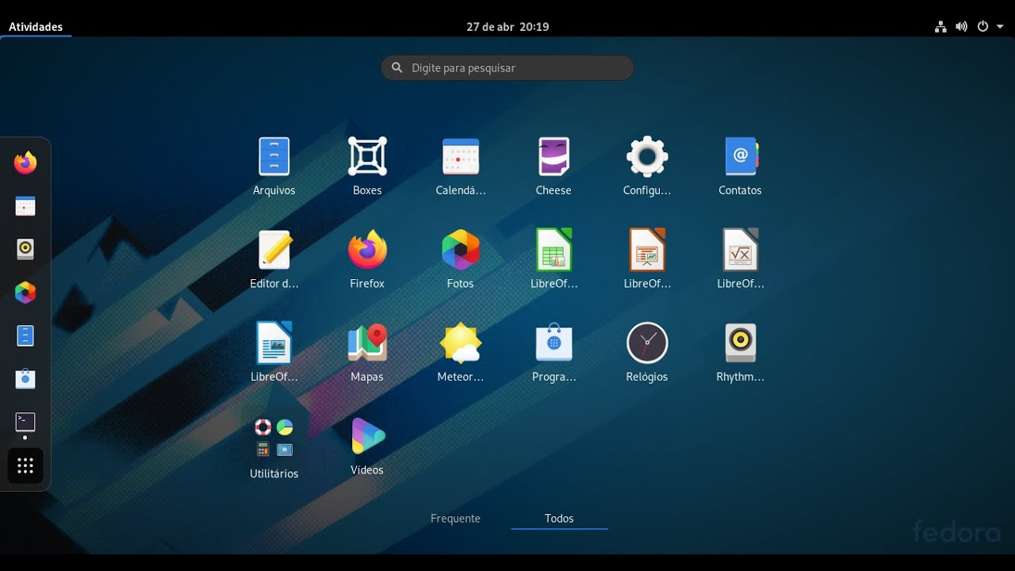

**Ubuntu 20.04 LTS Main Desktop:**

Ubuntu main desktop, much like fedora’s, provides navigation menu pinned on the left permanently. Additionally, you can add desktop icons. Any window/program that you run have the left pane fixed with it so that you can navigate to other apps using the mouse on the left pane. You can’t have desktop shortcuts pinned to screen area.

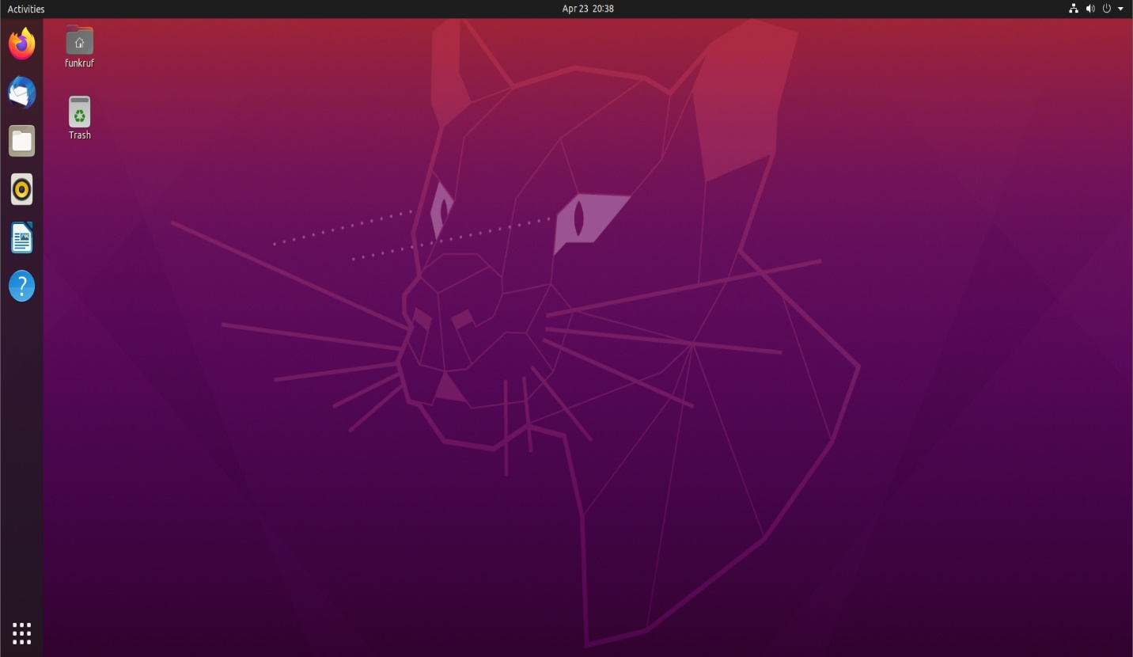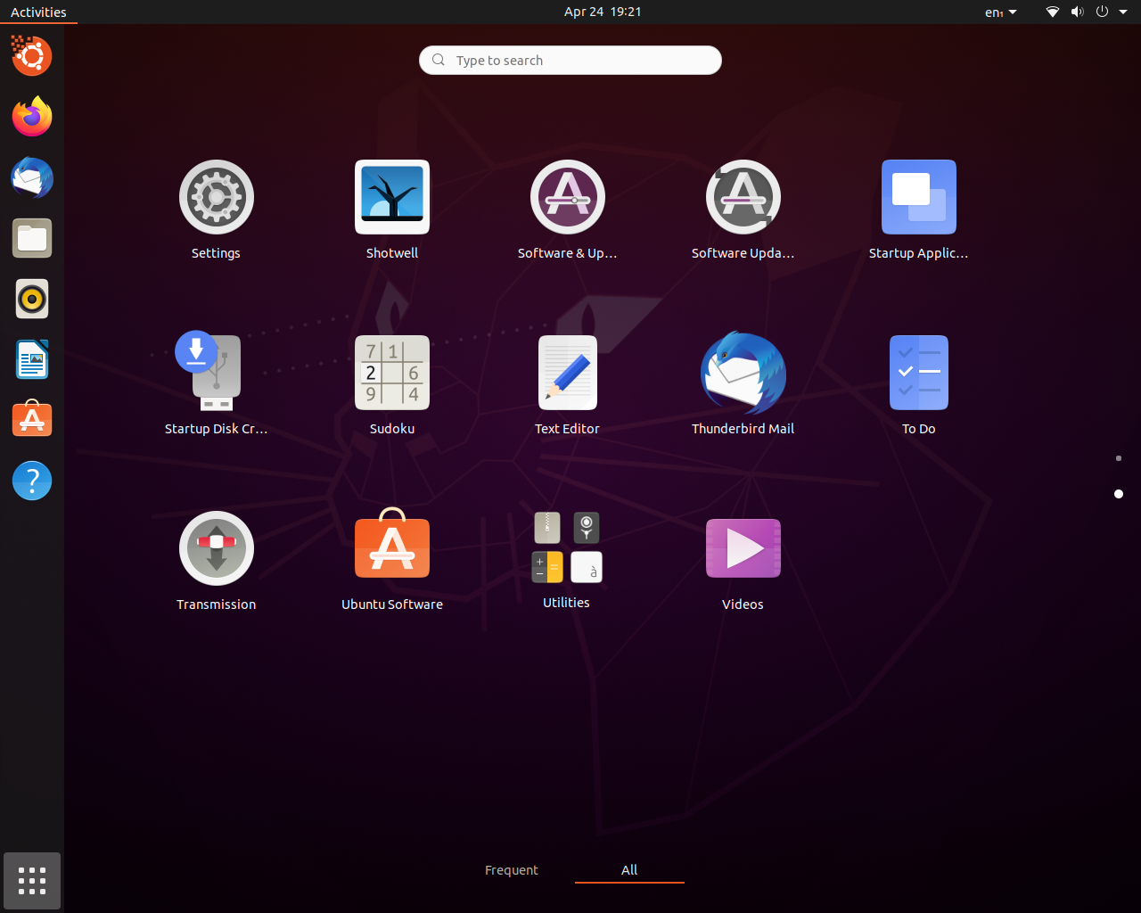

**Fedora 32 File Manager (Nautilus):**

It comes with a default lite theme, which can be changed to dark mode. It is simple and provides the same functionality as of Ubuntu’s Nemo. The color scene is reduced to minimum to enhance productivity. Nautilus pins bookmarks at the end of left pane. It doesn’t groups items in categories.

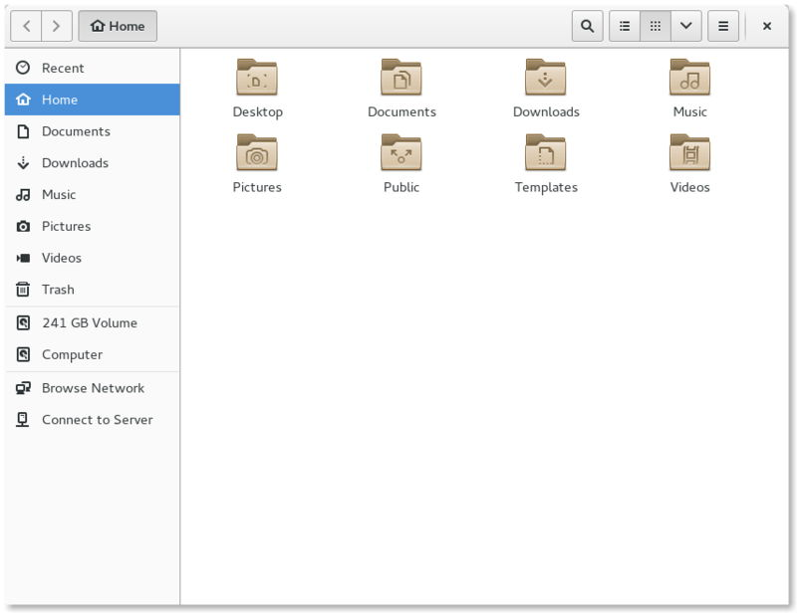

**Ubuntu 20.08 File Manager (Nemo):**

Nemo has a multicolor file manager which is a great choice for theme enhancers, but pinch in the eye for minimalists. You can select colors of your choice. Nemo pins bookmarks in the middle of left pane. It groups items in categories.

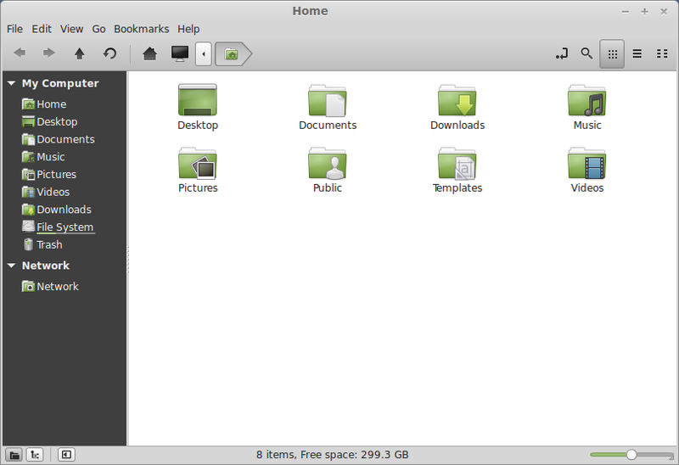

**Comparison of Both (Nautilus on the l eft and Nemo on the right):**

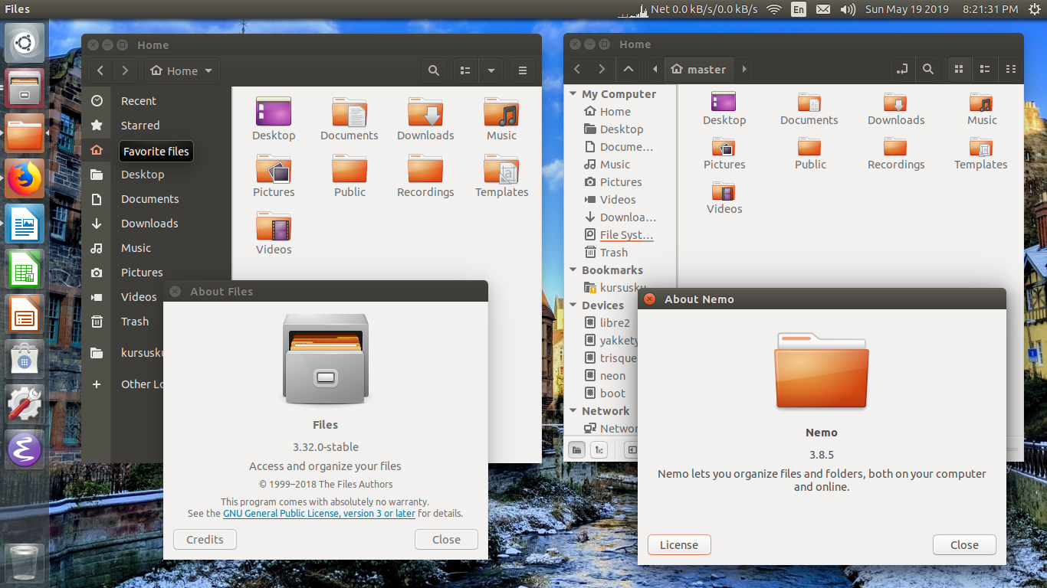

**Fedora 32 Settings Menu:**

A light interface, can be switched to dark, provides all of your system/device functionally in it. Fedora also provides Gnome tweak tools in it. They are preinstalled.

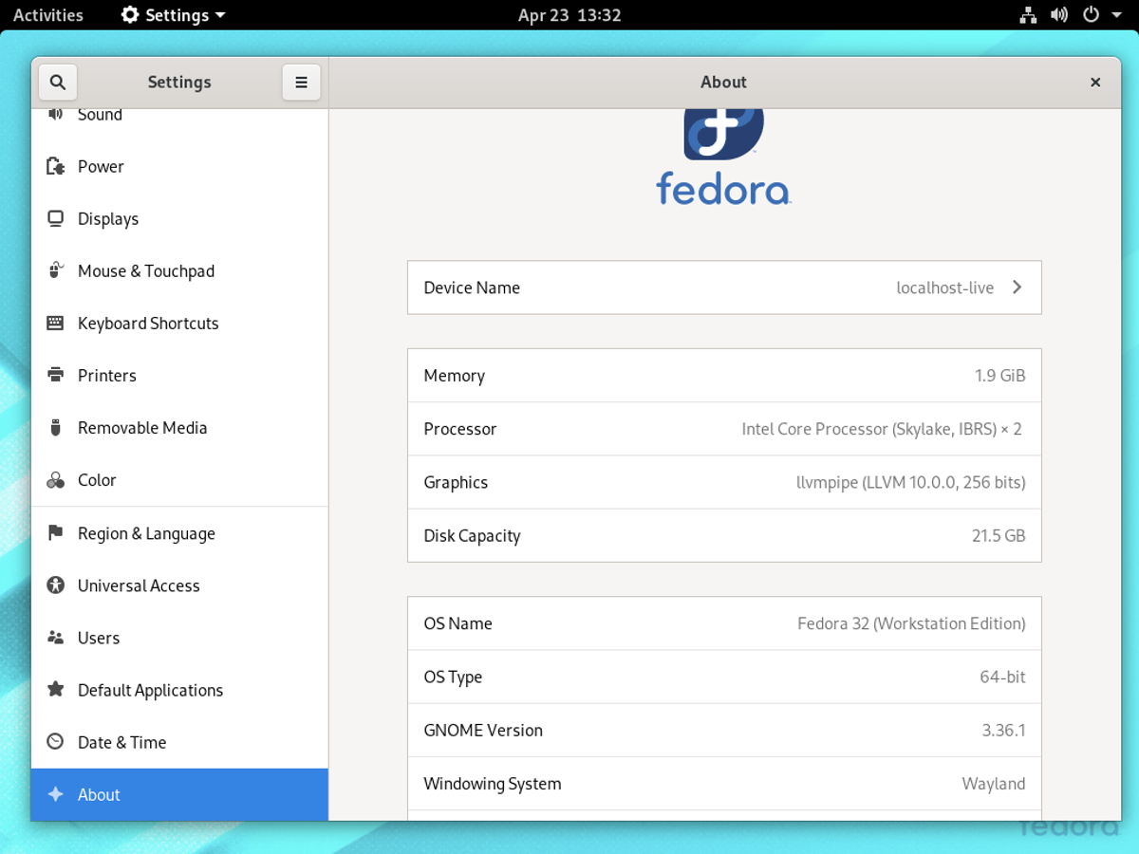

**Ubuntu 20.04 Settings Menu:**

Just a color tweak, like fedora, but Gnome tweak tools are not preinstalled.

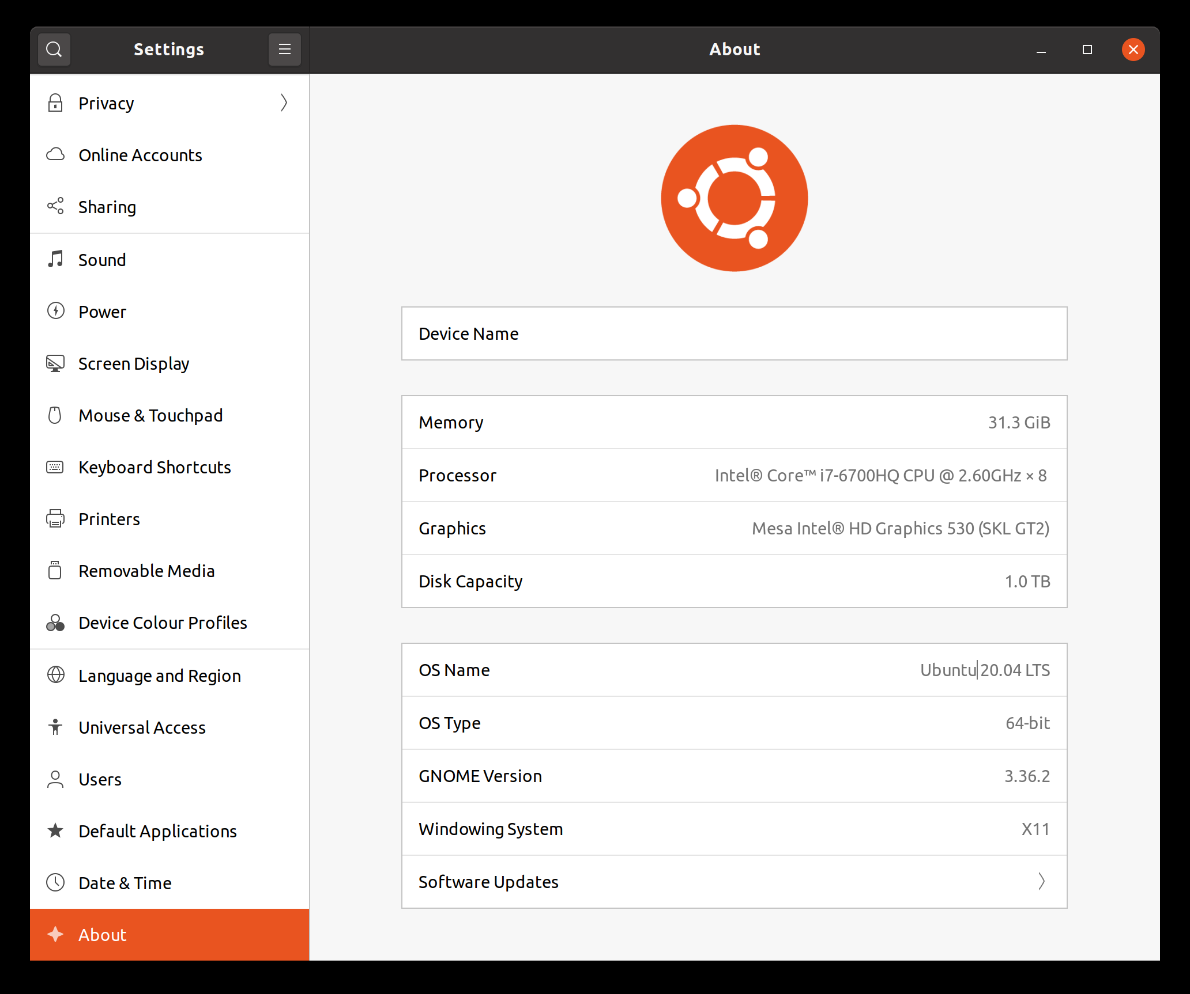

**Fedora 32 Software Center:**

Fedora Software center GUI is the worst part of Wayland. It is poor in color choice and doesn’t provides curated list of software’s. It is pretty much static and doesn’t change according to popularity. Worst item categorization.

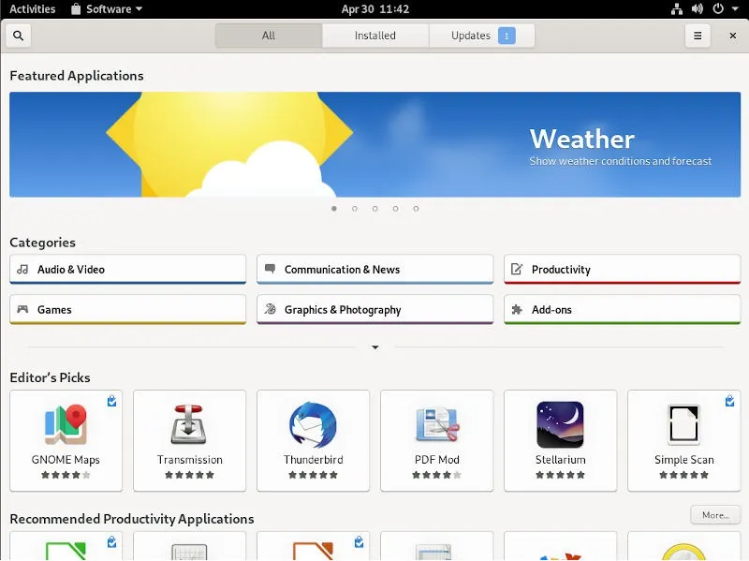

**Ubuntu 20.04 Snap Store:**

Ubuntu made a switch from Gnome Soft wears to its own Snap-Store. Snap-store is one of the latest software catalogues in the Linux world, followed by flat-hub. Great color choice and good categorization of items and it updates frequently according to popularity of items.

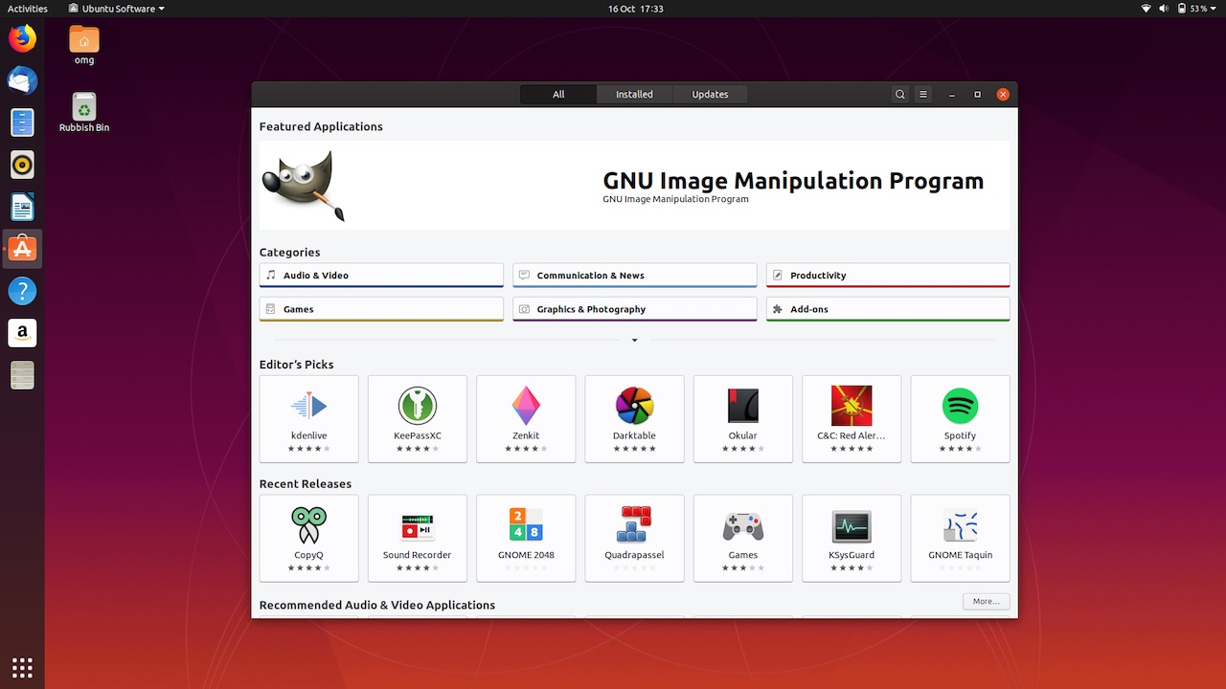

**Conclusion:**

Fedora 32 and Ubuntu 20.04 do provide one of the best and most accepted interfaces in the world of Linux. Both have its target audience. Both provides frequently accessed system functionality on the top left corner. Fedora 32 lacks in some features and Ubuntu provides some features that annoys a lot of people. Both have their goods and tradeoffs. It’s up to users to make their personal choice. I like minimalist design with full focus on the running app. So, I am using Fedora 32.